The Woodville Minor Hockey Executive wants to welcome all of our new and returning players back for the 2023-2024 season. We are excited for another year of hockey with our teams ranging from U5 and up!
Ice times will start the week of September 18, 2023. Please visit the calendar to determine your child’s first skate time.
On September 18 & 25 there will be a mouthguard clinic at the arena from 5-8:00 PM for those interested. This is being offered by Dental Hygiene Care by Marine. Prices range is $50-55.
Please log into your spordle profile (where you registered) to verify your players information is all up to date and there are no outstanding documents or issues with their account. https://page.spordle.com/woodville
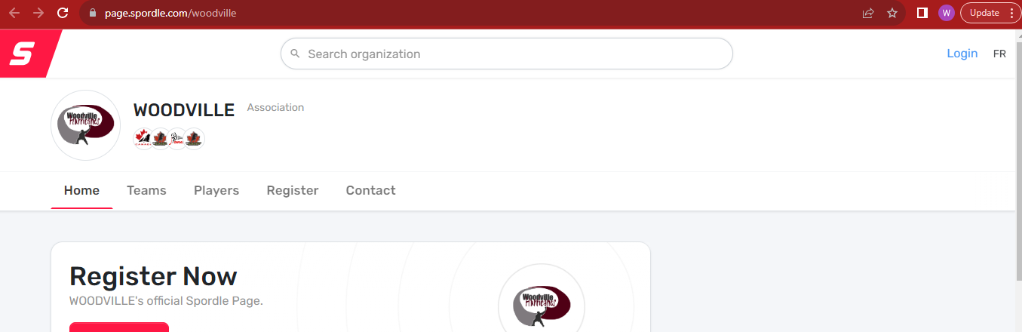

Respect In Sport
Just a reminder to all parents/guardians and spectators to review and adhere to the Respect in Sport guidelines, they can be found here https://cdn1.sportngin.com/attachments/document/0043/7522/fair_play_code1.pdf#_ga=2.111532420.1458381463.1656683587-1321564485.1635608441

Rowan’s Law
A reminder to all players parents/guardians of the concussion safety legislation. We encourage you to review the concussion awareness information found on the OMHA website prior to the start of the season, which can be found here: https://www.omha.net/news_article/show/1034907#:~:text=The%20OMHA%20is%20a%20leader%20in%20concussion%20management,that%20they%20have%20reviewed%20Ontario%E2%80%99s%20Concussion%20Awareness%20Resources
New To Hockey?
If you are new to hockey welcome, we are glad to have you onboard. Often new families have questions about what equipment is required for their player when they are starting out. All players require full equipment. Team Jerseys and socks will be issues later in the fall to be worn for games only (U9 and above). Our younger players will be issued Timbits jerseys and socks once they become available, until then please arrive with a practice jersey/socks.
Here is a link to helpful information regarding the equipment required https://www.omha.net/page/show/2796144-equipment
Food Booth
The food booth is back for another season (times to be determine). We are excited to once again be offering debit and credit in addition to cash for purchases.

Schedules
Your Childs team schedule can be found on the Woodville Minor Hockey website.
You can access the master calendar here https://woodvillehockey.com/Calendar/ that will show every teams ice times. Or you can go to your child’s specific team site by clicking on their age group (this is found at the top of the main page left hand side)
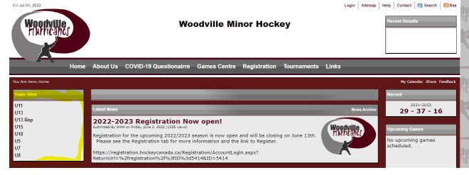
Families are strongly encouraged to check the calendar frequently to ensure they are up to date on the teams schedule (when games are rescheduled/cancelled this will be reflected on the calendar).
Hurricanes Gear
Hurricanes gear is available for sale through Lindsay Sportline here is a link to the available itemshttps://www.lindsaysportsline.com/collections/woodville-hurricanes
Social Media
Follow Us on Facebook for additional updated and information
https://www.facebook.com/pages/category/Sports-league/Woodville-Minor-Hockey-Association-347615852779255/

Meet Your Executive
The Woodville Minor Hockey Association is supported by a group of volunteers. Below is the contact information for the executive, should you have any questions or concerns please do not hesitate to contact us.
President | Matt Jackson | wmhpresident@gmail.com
Vice President | Joel Van Schaik | wmhvicepresident@gmail.com
Secretary | Holli Appleby-Joy | wmhsec@gmail.com
Treasurer | Tara MacArthur & Michelle Torrey | woodvillehockeytreasurer@gmail.com
Public Relations | Melanie Maryniuk | wmhaepr@gmail.com
OMHA Representative | Matt Jackson | wmh.omha.rep@gmail.com
Tri County Contact | Chris Joy | buck69_21@hotmail.com
Ice Scheduling | Jamie Mackay | wmhicescheduler@gmail.com
Fundraising | Vacant | Seeking volunteers, if interested contact Lauren Dunn
Coach Mentor | Bill Madill | wmhcoachmentor@gmail.com
Equipment Manager | Dwight Clark | wmh.equipment.manager@gmail.com
Booth Convener | Amanda Clark | wmhbooth@gmail.com
Director | Lauren Dunn | wmhdirector@gmail.com

Contact emails for the executive can also be found on the website here https://woodvillehockey.com/Staff/1004/
Questions or Concerns? If you have any questions or concerns you are encouraged to reach out to the executive for support.

